Ex No: 02  Date: | Scheduling of Project with PERT and CPM Techniques
Aim
To estimate the project completion time by creating a project schedule, defining task dependencies, generating the CPM and PERT network diagrams, assigning resources and costs, and calculating the overall project duration using ProjectLibre
Algorithm
- Open ProjectLibre.
- Create a new project.
- Enter project name and start date.
- Create project activities with durations.
- Define predecessor relationships.
- Generate Gantt Chart.
- Generate Network Diagram (PERT/CPM).
- Create Resource Sheet.
- Assign resource costs.
- Allocate resources.
- View Project Summary and Cost Report.
- Save the project

Procedure
Step 1: Create a New Project
- Open ProjectLibre.
- Click File → New.
- Enter:
  - Project Name: Software Project Scheduling
  - Manager: Your Name
  - Start Date: Select today's date.
- Click OK.

Step 2: Enter Project Activities
In the Gantt Chart, enter the following activities:
Task Name | Duration
Requirement Gathering | 2d
Feasibility Analysis | 3d
UI/UX Design | 4d
Database Development | 5d
Application Development | 6d
System Testing | 3d
Bug Resolution | 2d
Project Deployment | 1d

Step 3: Enter Predecessors
In the Predecessors column, enter:
Task | Predecessor
Requirement Gathering | -
Feasibility Analysis | 1
UI/UX Design | 2
Database Development | 3
Application Development | 4
System Testing | 5
Bug Resolution | 6
Project Deployment | 7
ProjectLibre will automatically schedule the project.

Step 4: View the Gantt Chart
After entering the tasks and predecessors:
- The Gantt Chart will be generated automatically on the right side.
- This shows the start date, finish date, and duration of each activity.

Step 5: View the Network Diagram (PERT/CPM)
- Click View.
- Select Network Diagram.
ProjectLibre automatically creates the PERT/CPM Network Diagram showing the sequence of project activities.

Step 6: Create Resources
Go to View → Resource Sheet and enter:
Resource Name | Standard Rate
Arun Kumar | ₹2000/day
Priya Sharma | ₹1800/day
Karthik Raj | ₹2500/day
Nisha Devi | ₹2200/day
Rahul Verma | ₹2700/day
Deepika S | ₹2100/day
Ajay Kumar | ₹1900/day
Meena R | ₹2300/day

Step 7: Assign Resources
Return to the Gantt Chart.
Assign the resources:
Task | Resource
Requirement Gathering | Arun Kumar
Feasibility Analysis | Priya Sharma
UI/UX Design | Karthik Raj
Database Development | Nisha Devi
Application Development | Rahul Verma
System Testing | Deepika S
Project Deployment | Meena R
Bug Resolution | Ajay Kumar

Step 8: View Project Summary
After assigning resources:
- Click Project or Reports (depending on your ProjectLibre version).
- View:
  - Total Duration
  - Total Cost
  - Resource Allocation
Observation:
Project Duration: 26 Days 208 Hours
Requirement Gathering → Feasibility Analysis → UI/UX Design → Database Development → Application Development → System Testing → Bug Resolution → Project Deployment
Critical Path:

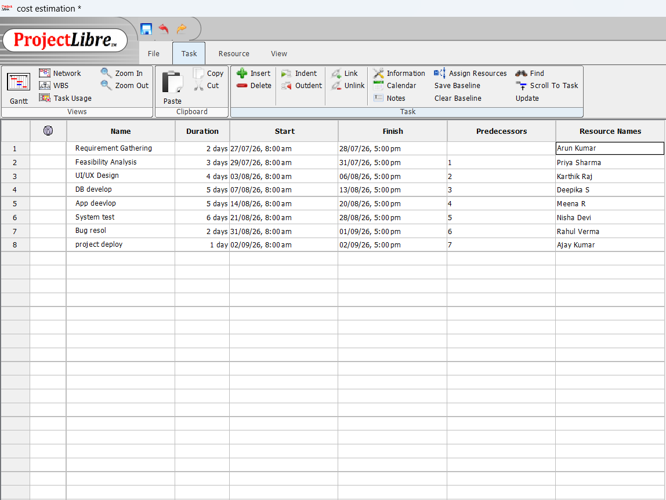

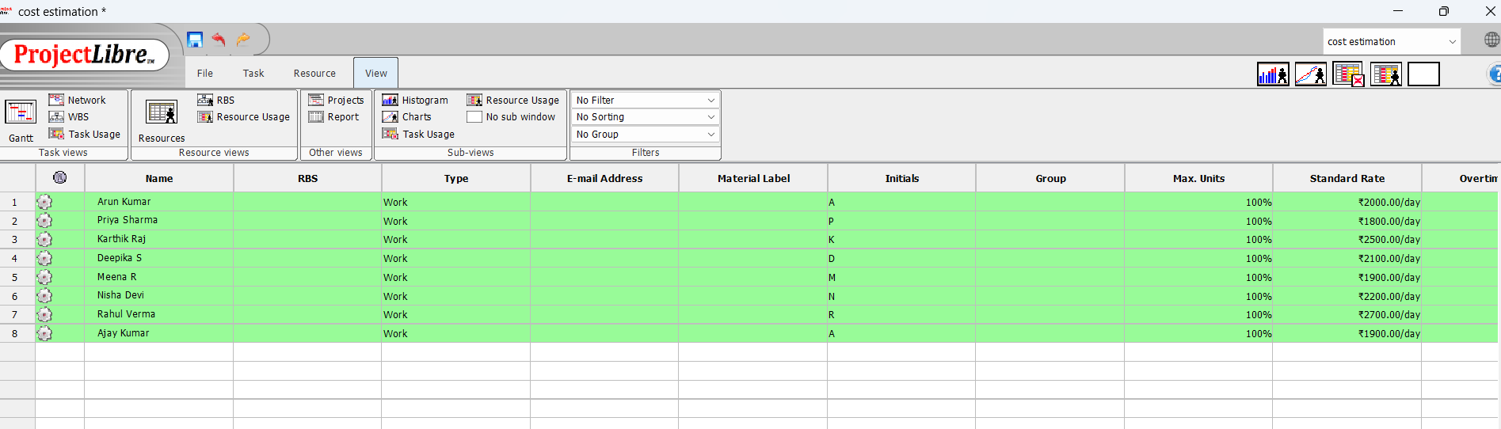

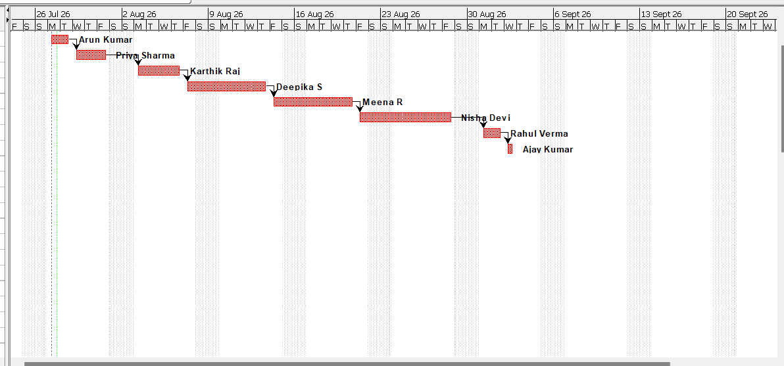

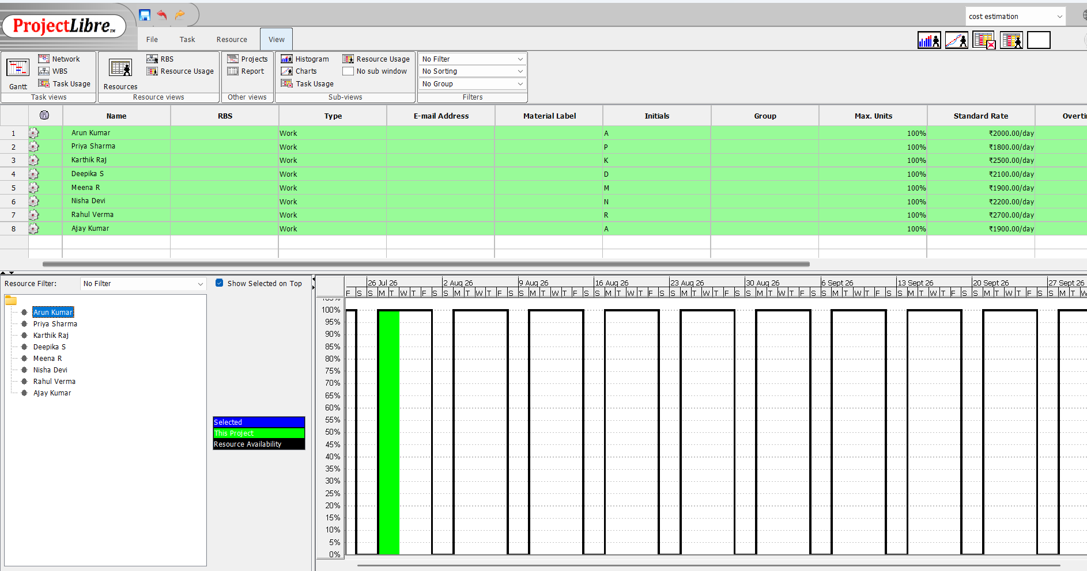

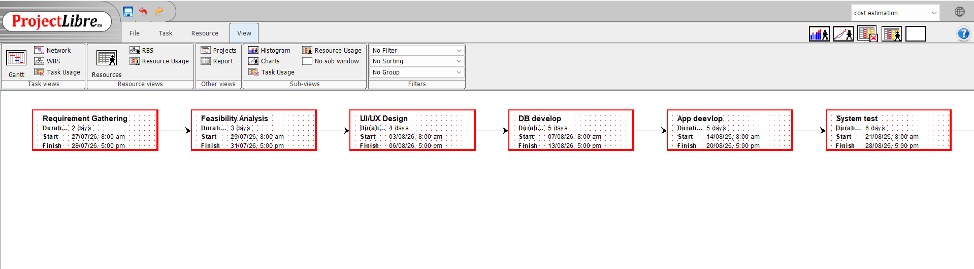

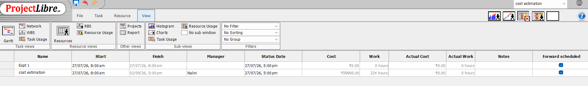

Result:
The project schedule was successfully created using PERT and CPM techniques in ProjectLibre. The software automatically generated the Gantt Chart and Network Diagram, identified the critical path, and estimated the project completion time of 26 days (208 hours).

